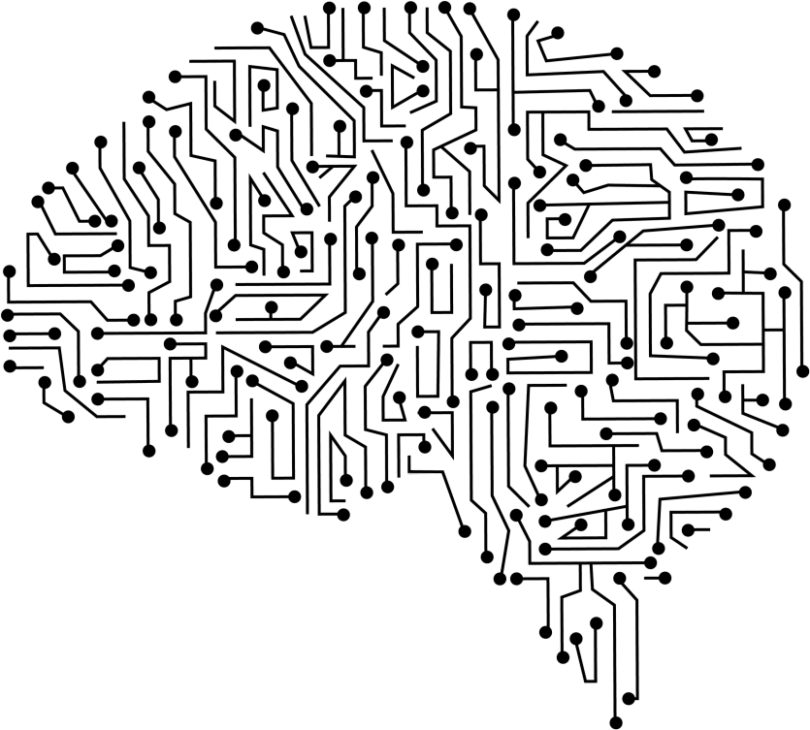
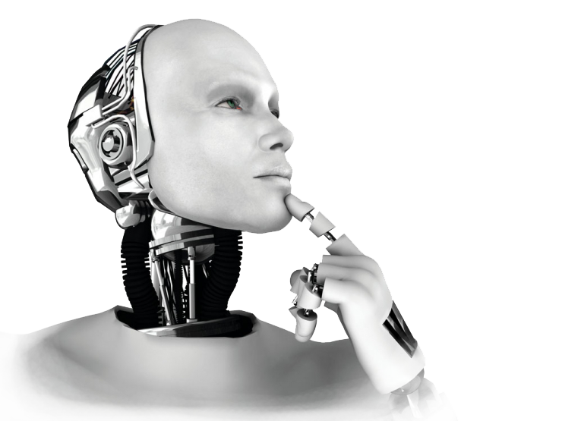

By
Shivam Kumar Giri

What is Strong AI and Weak AI with examples

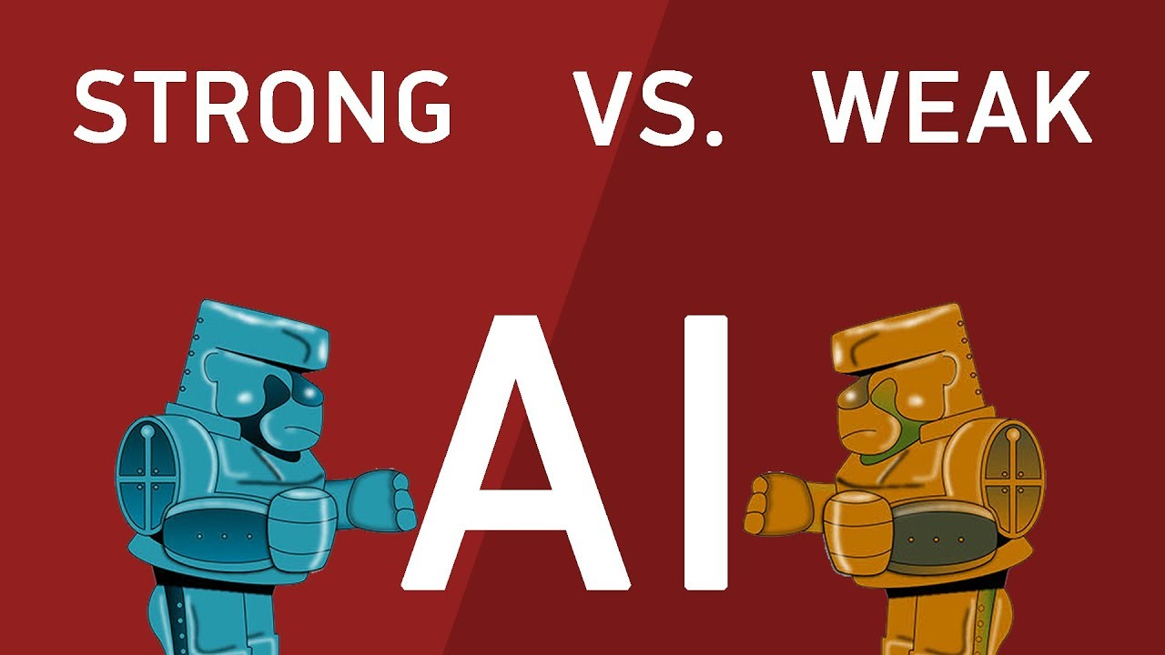

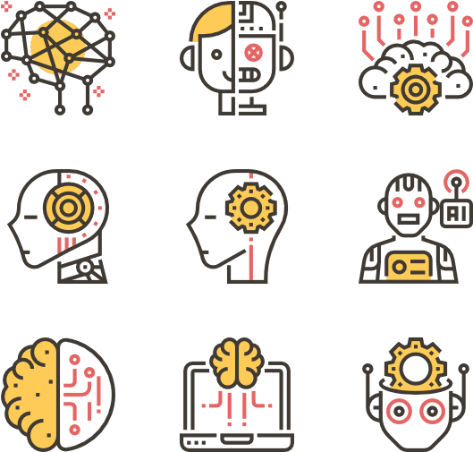

Weak AI
Definition
Weak AI form of artificial Intelligence that are used for specific application domain and may used to solve complex problems in the specific domain they are trained with.
These are system programmed to accomplish wide range of problems’ but operate within a pre-defined range of functions.
These are also known as Narrow AI as it is related to specific area

Capabilities of domain
- Logical thinking
- Making decision in case of Uncertainty
- Plan and learn
- Communication and Natural language Processing
- A common Goal is achieved via the abilities processed
- Are modelled on intelligent behavior
- Limited intelligence
- Take over vertical task over Human Brain
- Not intended to match/exceed human intelligence

Example
Alexa, Cortona, Siri



Strong AI
Definition
The form of artificial intelligence which as same intellectual abilities as human or even surpass them.
These are the Hypothetical machine that exhibit human cognitive abilities.
These are the machines that have minds of there own and can be able to accomplish complex task of their own
Capabilities
- Expert systems
- Navigation Systems
- Voice Recognition System
- Character Recognition system
- Auto correct Functionalities
- Complex task on their own
- Exhibits human cognitive abilities
- Decision Making abilities on their own
- Tend to match/exceed human intelligence
Example
Strong Intelligence is now just Hypothetical and intended to develop by 2030/ 2045.
As of Now we can claim ‘Sophia- the robot’ as some level of strong AI. But still now need lots of processing to be Strong AI
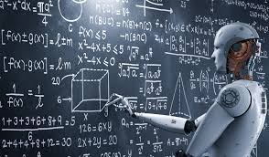
CONCLUSION

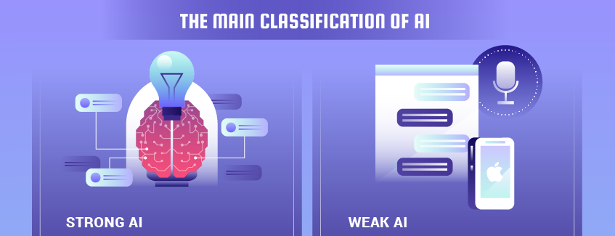
As evidently appears, both the positions leave open some relevant issues, especially from philosophical and moral point of views, paying several questions with difficult answers.
Now, we can only analyze that in the last years the theories on Artificial Intelligence tried to overcome this dichotomy, coming to the conclusion that a machine can be considered intelligent only when able to reproduce how a human brain works on a cellular level.
